CRM APPLICATION THAT HELPS TO BOOK A VISA SLOT

INTRODUCTION:

1.1 OVERVIEW

A visa slot management project is a system that is used to track and manage the availability of visa slots, which are appointments that are required for certain visa applications. It might be used by a government agency or a visa processing center to schedule and manage appointments with applicants.

1.2 PURPOSE

A visa is a permit given by a country that allows someone to go to that country. A visa is a document that is stamped on a person’s passport by an embassy. It names the kind of visit and says how long the person can stay.

The main difference between a visa and a passport is that a visa is an endoresement placed within a passport that grants the holder official permission to enter, leave or stay in a country for a specified time period. The most common visa types are tourist, students, work and transit visas.

EMPATHY MAP
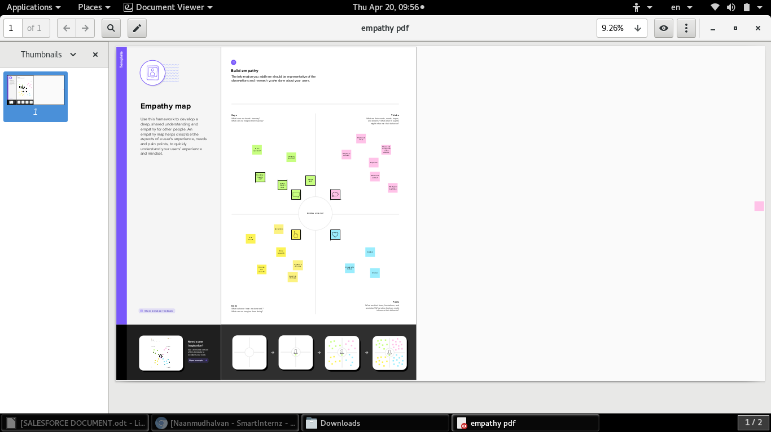
BRAINSTORM & IDEA PRIORITIZATI

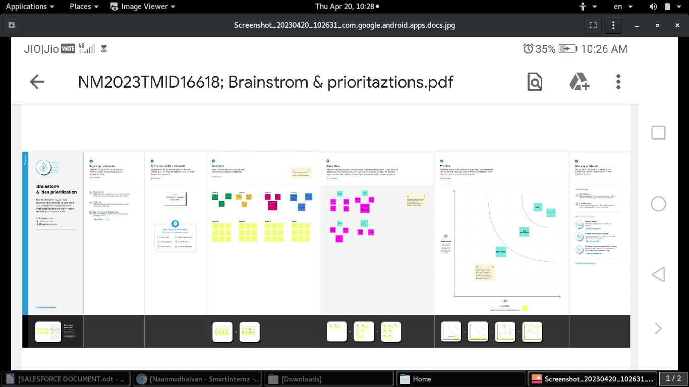

MILESTONE-1

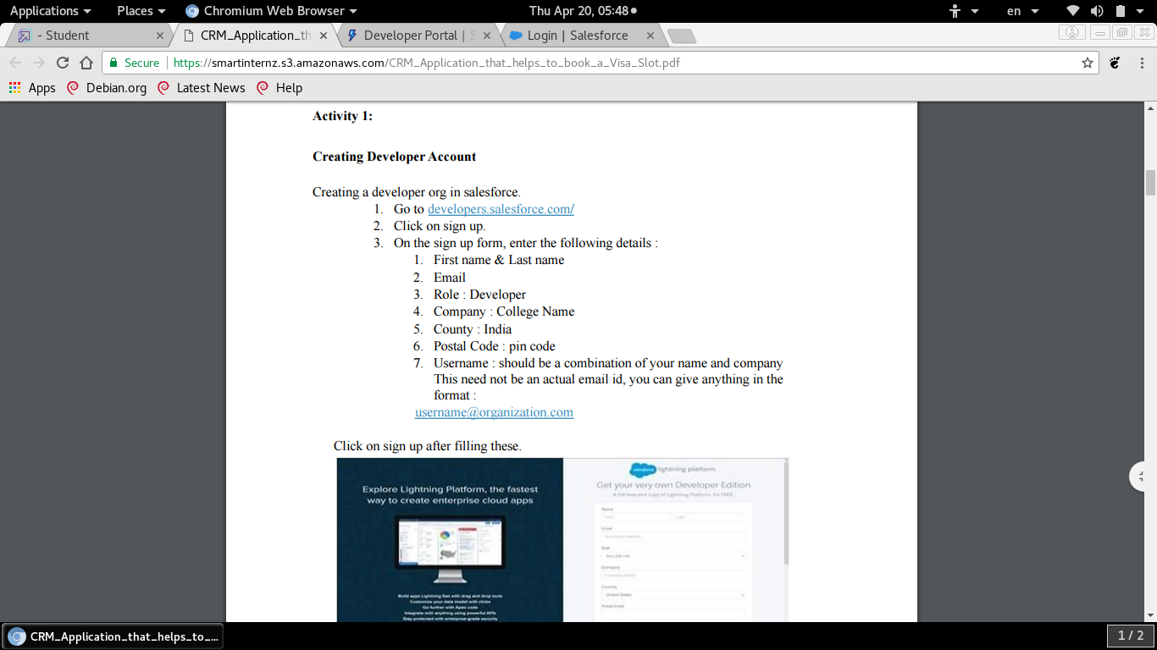

Activity 1:

Creating Developer Account

Creating a developer org in salesforce.
1) Go to developers.salesforce.com/
2) Click on sign up.
3) On the sign up form, enter the details.

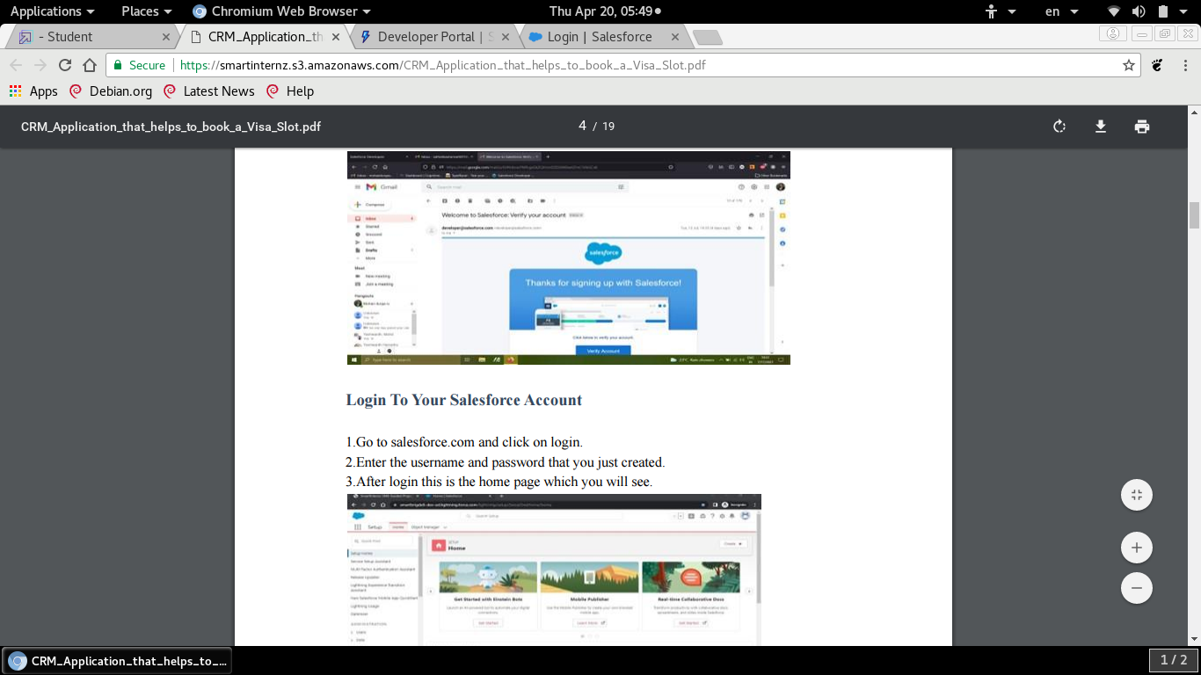

Login to your salesforce account

1) Go to salesforce.com and click on login.
2) Enter the user name and password that you just created.
3) After login this is the home page which you will see.

Salesforce Login

https://login.salesforce.com
MILESTONE-2 : OBJECTS:

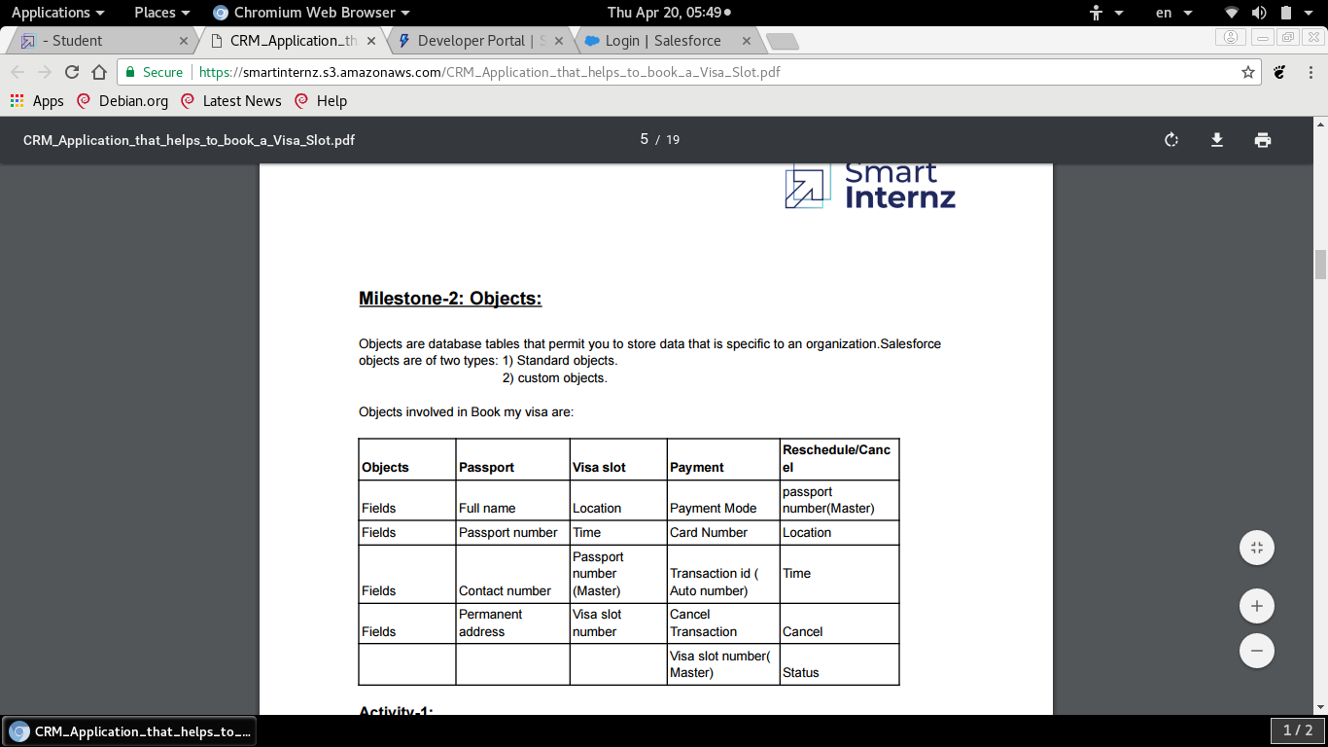

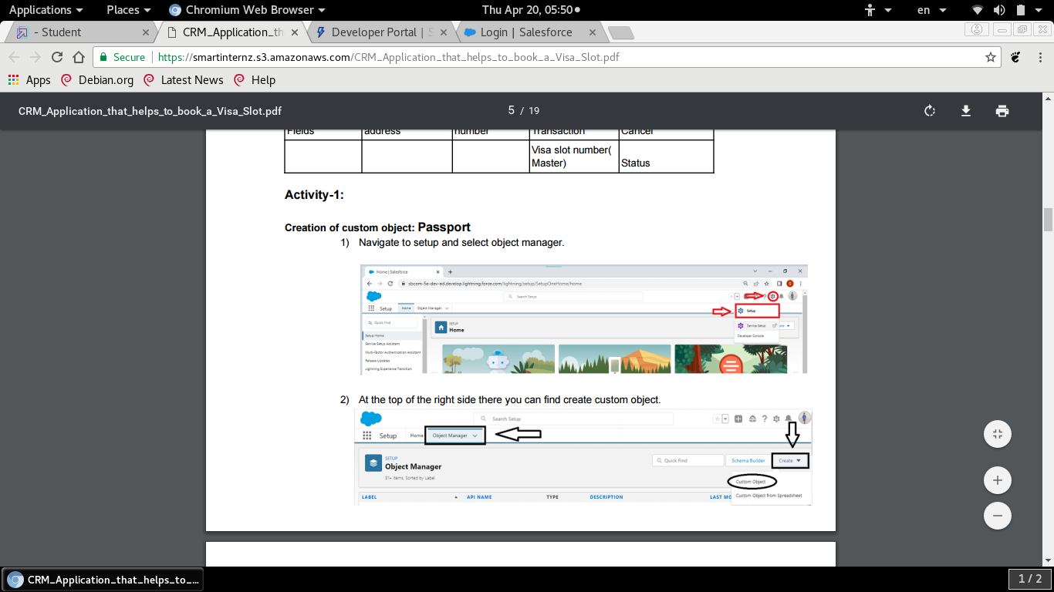
ACTIVITY 1:

Creation of custom object: PASSPORT
Creation of custom object: VISA SLOT
Creation of custom object: PAYMENT
Creation of custom object: RESCHEDULE/CANCEL

ACTIVITY 2:

Fields available on custom object:

FIELD NAME DATA TYPE

1) Contact number Number
2) Full name Text
3) Passport number Text
4) Permanent address Text

MILESTONE -3: RELATIONSHIP B/W OBJECTS:

Relationship in salesforce is a two -way association between two objects. Using relationships we can link objects with each other and we can make connections and display data about other related objects.

ACTIVITY-1

CREATION OF RELATIONSHIP:

To create a Master Detail relationship between Passport and Visa.

1) Go to the Set Up option from the Home Page and click on it.
2) Go to the object manager and select ‘visa’ object from the list.
3) And select fields and relationships and click on new.
4) Select the data type has Master Details relationship.
5) And select related to the object has passport, and click on next.
6) You will navigate to the label name page value give the label name for the field, give it has passport number and click next.
7)Select visible for all profiles in field level security and select page layout in next page and save it.
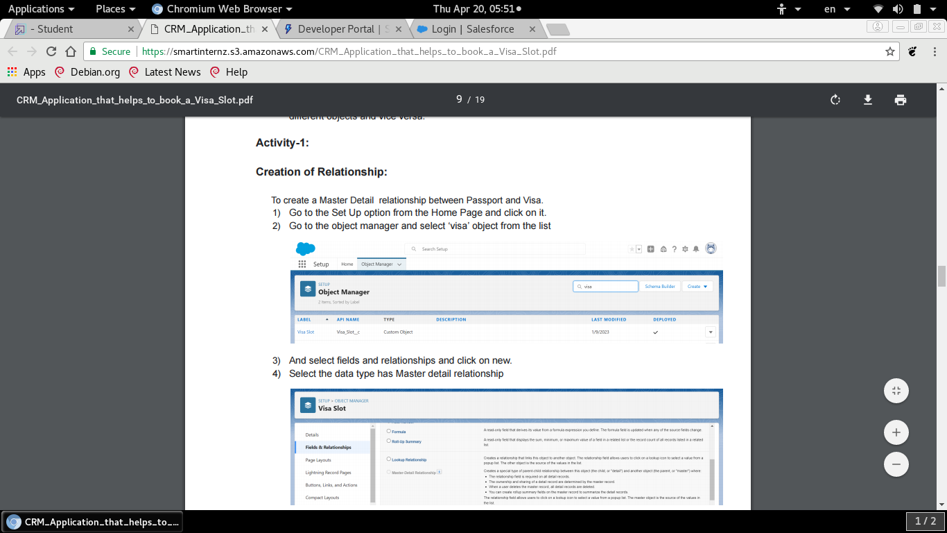

MILESTONE-4

Apps in salesforce are a group of tabs that help the application function by working together as a unit. It has a name, a logo, and a particular set of tabs. The simplest app usually has just two tabs.

There are two types of salesforce Application:

1) Standard App
2) custom Apps

ACTIVITY:

CREATION OF APP

An app is a collection of items that works together toserve a particular function. Salesforce apps come in two flavors: Classic and Lighting.

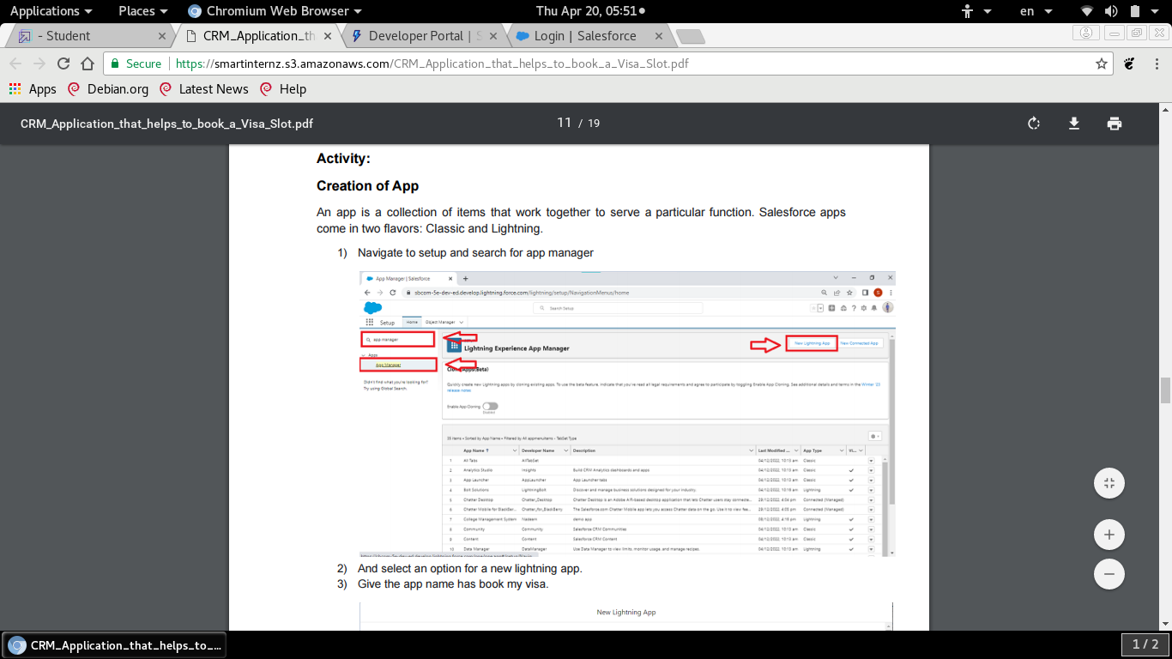

NEW LIGHTING APP
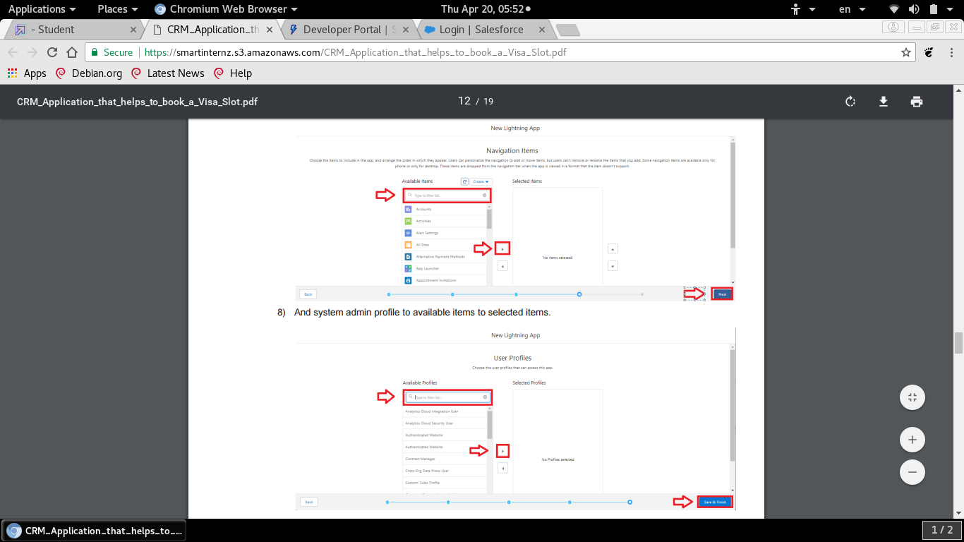

MILESTONE-5 User:

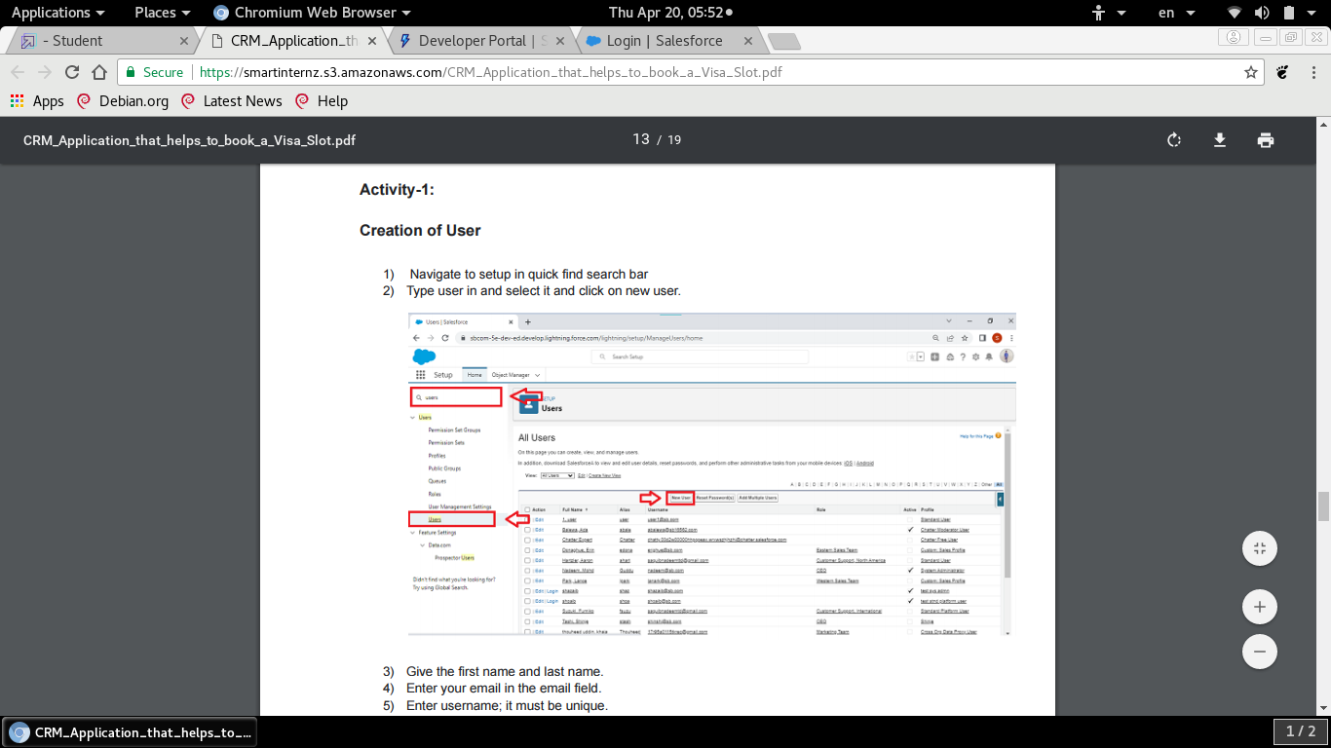
A user is anyone who logs in to salesforce. Users are employees at your company, such as sales reps, managers, and it specialists, who need access to the company’s records.

ACTIVITY-1 CREATION OF USER

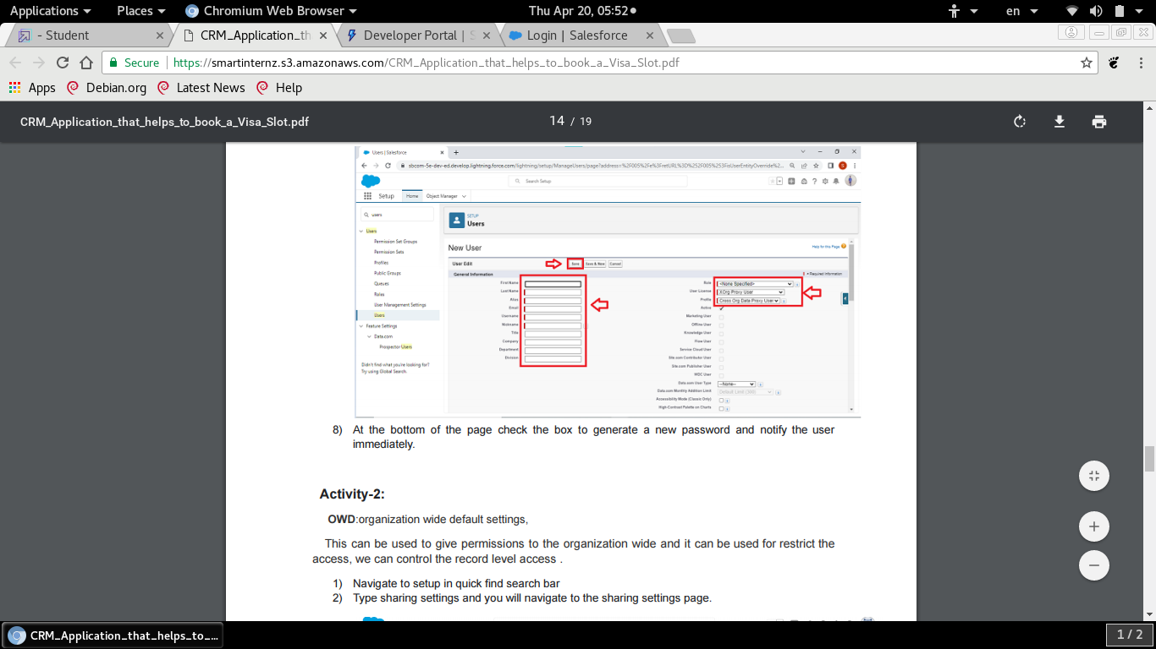
ACTIVITY-2:

OWD: ORGANIZATION WIDE DEFAULT

This can be used to give permissions to the organisation wide and it can be used for restrict the access, we can control the record level access.

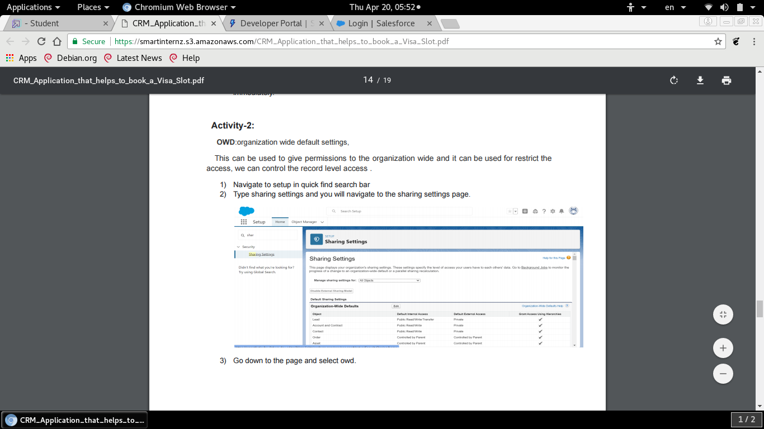

MILESTONE-6 REPORTS:

A report is a list of records that meet the criteria you define. It’s displayed in salesforce in rows and columns , and can be filtered, grouped, or displayednin a graphical chart. Every report is stored in a folder. Folders can be public, hidden, are shared and can be set to read-only read/write.

ACTIVITY-1:

CREATION OF REPORT

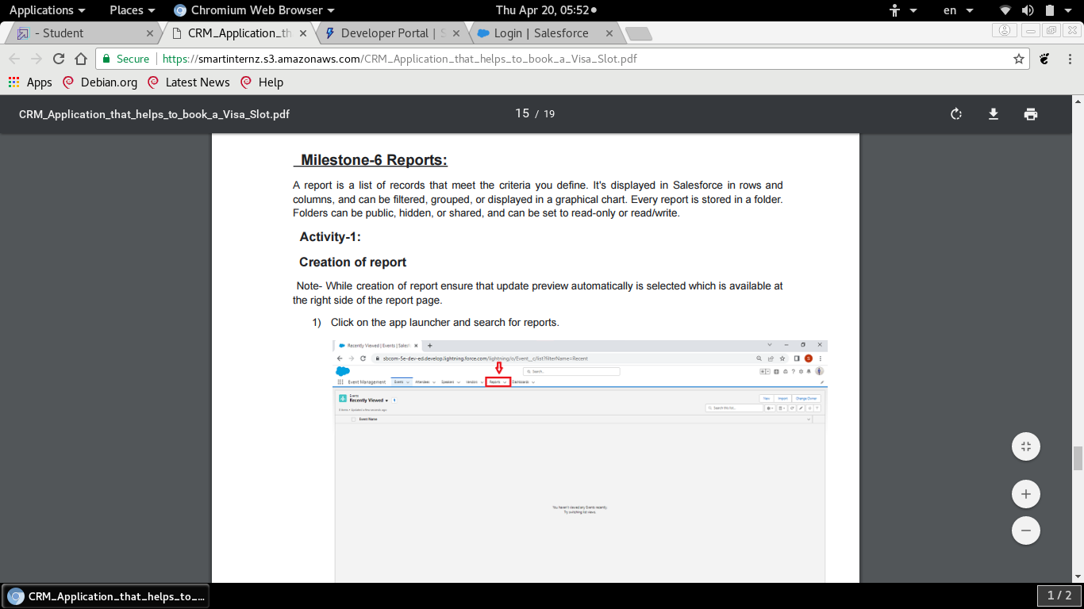
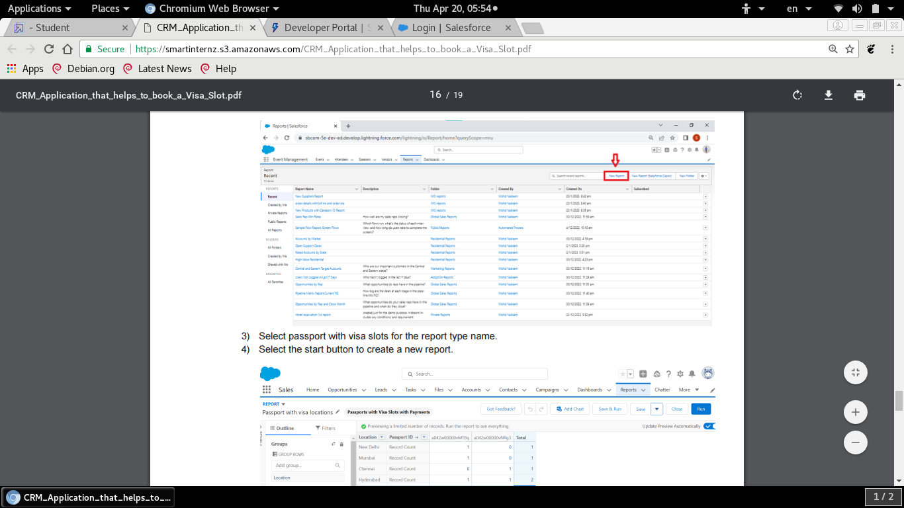
click on app launcher and search for reports. And select a new report type category select other reports. Select passport with visa slot type name. Select the start button to create a new report.

MILESTONE-7 DASHBOARDS:

Dashboards in salesforce are a graphical represtation of reports it shows data from source reports as usual visual components.

ACTIVITY

CREATION OF DASHBOARDS

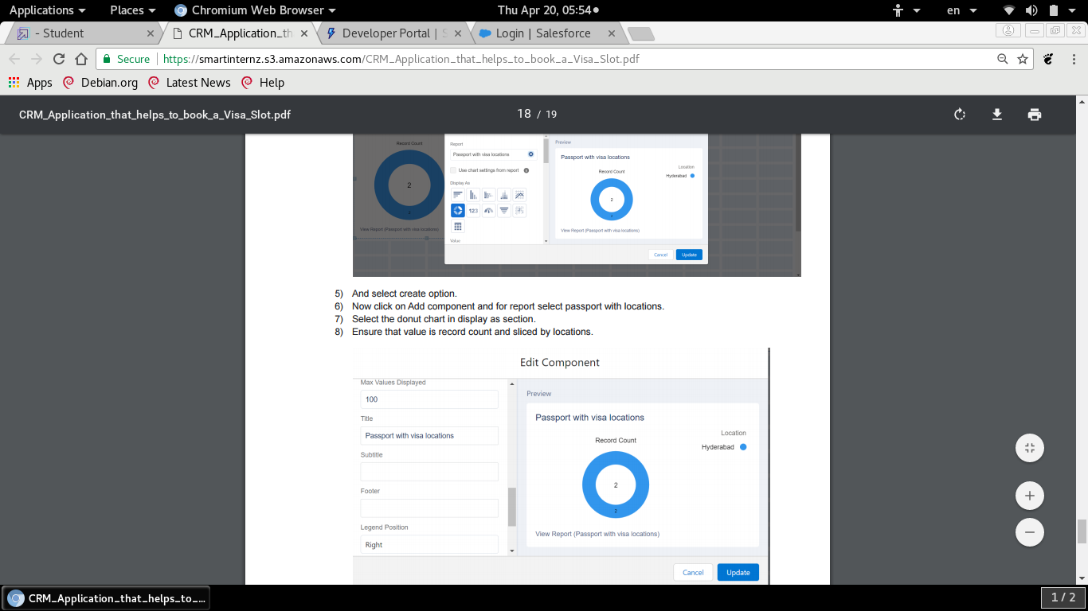

Click on the app launcher and search for dashboards. Select the new dashboard option name the dashboard has a passport and visa locations.
And select create option . Now click on Add component and for report select passport with locations.

Select the donut chart in display as section .Ensure that value is record count and sliced by locations. Leave the default values click on add. Save the dashboards

URL CODE

Team Lead (V.Priya)- https://trailblazar.me/id/pviji2
Team member 1 ( T.Monal) – https://trailblazer.me/id/monat15
Team member 2 ( D.Gracy) – https://trailblazer.me/id/gracyd
Team member 3( G.Thulasi) – https://traillblazer.me/id/tgopal16

2ADVANTAGES OF BOOKING A VISA SLOTS:

The full form of VISA is Visitors International Stay Admission. It is a global elctronic system used by governments and financial institutions to process visas and other immigration-related documents
1) VISA allows you to travel to a port of entry, airport or land border crossing, and request permission of the Department of Homeland security (DHS), Customs and Border protection(CBP) inspector to enter the United State
2) Visas are necessary if you’d like to travel to a country that does not have a visa policy in place with your home country. Many countries have visa policies and agreements that allow their citizens to travel freely between them without the need for a visa.
3) When the application is approved, the visa is sent to the email and can be downloaded. One of the major benefitsof e-visa is that you don’t have to wait at the airport after arrival in the country.

4) The US student visa is one of the fastest visas to process. In fact, the study permit is often processed directly before your embassy interview.

DISADVANTAGES OF BOOKING A VISA SLOT

1) Cost of visa slot and Cost of visa stamping

2) Technical issues

3) It take more time

4) The officers specifically check for financial documents during the visa interview to ensure that you have the necessary funds to pay for tuition fees, accommodation, living expenses, etc., in a foreign land.

5) Any criminal history you have.

6) In online application many fraud cases will appears.

APPLICATIONS

A visa slot management project is a system that is used to track and manage the availability of visa slot, which are appointments that are required for certain visa applications. It might be used by a government agency or visa processing center to schedule and manage appointments with applications.

This will help you to track and manage the availability of visa slots,which are appointments that are required for entire visa applications.

An education agency’s system that gives your the flexibility of working the way you prefer, always. Education Link is fully customizable to allow you to deal with any type of process : migration agencies, tourism agencies, student agencies, onshore and offshore students, multiple enrollment methods, and more.
CRM is Customer Relationship Management software that helps business et systemized and also aids them to grow sales, enhance marketing ROI, and deliver satisfying customer service experiences. Vtiger has designed their integrated features to go beyond those found in a standard CRM system.

CRM system not only helps you improve the customer services but also assitss the entire organization to further evolve the customer-centric approach along with insights on which area to improvise in.

The CRM systems helps companies stay connected to their customers, it acts as a tool used for
contact management, productivity, sales management and more.

CONCLUSION

A visa slot management project is a system that is used to track and manage the availability of visa slots, which are appointments that are required for certain visa applications. There many advantages and disadvantages are in the process booking of visa slot. Especially, in the online and agency sysems. We are aware in agencies because many agencies are fraud. In online case also we are in allot .
Applicants must make a successful payment before they are permitted to schedule their interview appointment. Applicants who do not pay the correct fee for their visa type may be restricted from scheduling an interview.
You can reschedule your US non-immigrant visa appoint by calling the embassy directly or by making the changes in date and time on line. The appointments will be pushed to the next available time period that works for you.
You can cancel your appointment only one time and reschedule the appointment. After the second cancellation you will have to pay the visa application fee again before being able to reschedule the appointment again.

FURTHER SCOPE

In a word -transformation. Global have beenworking together very cosely in order to create an online, integrated application process. The digitisation move was going to taken offering a more efficient, reliable customer service globally.
The visa customers care about three thngs – convenience, processing time and cost. And in future we have designed our services to give customers the greatest possible choice across these three priorities.
1) Cost of visa slot and Cost of visa stamping

2) Technical issues

3) It take more time

4) The officers specifically check for financial documents during the visa interview to ensure that you have the necessary funds to pay for tuition fees, accommodation, living expenses, etc., in a foreign land.

5) Any criminal history you have.

6) In online application many fraud cases will appears.

APPLICATIONS

A visa slot management project is a system that is used to track and manage the availability of visa slot, which are appointments that are required for certain visa applications. It might be used by a government agency or visa processing center to schedule and manage appointments with applications.

This will help you to track and manage the availability of visa slots,which are appointments that are required for entire visa applications.

An education agency’s system that gives your the flexibility of working the way you prefer, always. Education Link is fully customizable to allow you to deal with any type of process : migration agencies, tourism agencies, student agencies, onshore and offshore students, multiple enrollment methods, and more.
CRM is Customer Relationship Management software that helps businesss and also aids them to grow sales, enhance marketing ROI, and deliver satisfying customer service experiences has designed their integrated features to go beyond those found in a standard CRM system.

CRM system not only helps you improve the customer services but also assists the entire organization to further evolve the customer-centric approach along with insights on which area to improvise in.

The CRM systems helps companies stay connected to their customers, it acts as a tool used for
contact management, productivity, sales management and more.

CONCLUSION

A visa slot management project is a system that is used to track and manage the availability of visa slots, which are appointments that are required for certain visa applications. There many advantages and disadvantages are in the process booking of visa slot. Especially, in the online and agency sysems. We are aware in agencies because many agencies are fraud. In online case also we are in allot .
Applicants must make a successful payment before they are permitted to schedule their interview appointment. Applicants who do not pay the correct fee for their visa type may be restricted from scheduling an interview.
You can reschedule your US non-immigrant visa appoint by calling the embassy directly or by making the changes in date and time on line. The appointments will be pushed to the next available time period that works for you.
You can cancel your appointment only one time and reschedule the appointment. After the second cancellation you will have to pay the visa application fee again before being able to reschedule the appointment again.

FURTHER SCOPE

In a word -transformation. Global have been working together very closely in order to create an on line, integrated application process. The digitalization move was going to taken offering a more efficient, reliable customer service globally.
The visa customers care about three things – convenience, processing time and cost. And in future we have designed our services to give customers the greatest possible choice across these three priorities.

